**Custom Site Strong Infinity**

**Clone My First Drupal Website - 2 ways:**

1. Acquia Dev Desktop 2 => Start from scratch, I don’t have an existing Drupal site => Drupal 8 – Install => Local codebase folder: custommagazinedrupal-8.5.5; Local site name: **custommagazine** … Database: Start with MySQL database dump file; Dump file: Browse: drupal8magazinewebsite1.sql … Finish;

Copy – Paste the folder from the original site drupal8magazinewebsite1; **Clear cash!**

1. Acquia Dev Desktop 2 => click on the site I want to clone => click More (down left) => Clone local codebase => Local codebase folder: custommagazine-clone; Local site name: **custommagazine-clone** ; PHP…; OK;   
   **Clear cash!**

*Roles: PePsi => p: ***** Editor => p: editor*

Base Themes: <https://www.drupal.org/project/project_theme> => <https://www.drupal.org/project/bootstrap>

The files are in <site-folder>\sites\default\files

*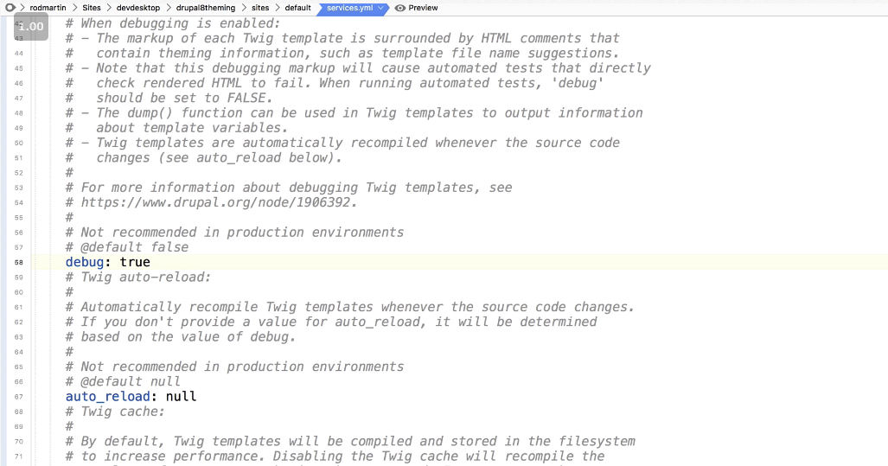***<site-folder>\sites\default\default.services.yml =>** *change debug:* ***true => drush cr***

**How to use jQuery in Drupal 8**

<https://www.drupal.org/docs/8/theming-drupal-8/adding-stylesheets-css-and-javascript-js-to-a-drupal-8-theme>

in main.js insert this:

**(function ($, Drupal, drupalSettings) {**

**'use strict';**

**// some jquery code**

**})(jQuery, Drupal, drupalSettings);**

In the folder of the site **\themes\** create new folder named **custom\**stronginfinity**\**stronginfinity**.info.yml =>**

**name: Strong Infinity**

**type: theme**

**description: Fresh Custom Theme For Magazine**

**core: 8.x**

**base theme: bootstrap**

**screenshot: screenshot.png**

**libraries:**

**- stronginfinity/stronginfinity-global**

**- stronginfinity/opensans**

**regions:**

**navigation: 'Navigation'**

**navigation_collapsible: 'Navigation (Collapsible)'**

**header: 'Top Bar'**

**highlighted: 'Highlighted'**

**help: 'Help'**

**content: 'Content'**

**sidebar_first: 'Primary'**

**sidebar_second: 'Secondary'**

**footer: 'Footer'**

**page_top: 'Page top'**

**page_bottom: 'Page bottom'**

in **\themes\custom\stronginfinity\** create stronginfinity**.libraries.yml** =>

**stronginfinity-global:**

**css:**

**css/style.css: {}**

**js:**

**js/main.js: {}**

**dependencies:**

**- core/jquery**

**- core/drupalSettings**

**opensans:**

**css:**

**theme:**

**https://fonts.googleapis.com/css?family=Open+Sans: { type: external }**

**css/style.css: {}**

Chrome => CTRL + Shift + N (New incognito window) => open the site here, so you won’t have to clear the cash

How to clear the cash => tools / Clear browsing data (chrome://settings/clearBrowserData)

Appearance / Global settings => Logo image…. Favicon..

**How to show the Future events aside:**

*Structure / Block layout / tab Strong Infinity => in Secondary – Place block => Sidebar Events …*

*=> in Secondary –* ***Sidebar Events*** *–* ***Configure*** *=> check Display title; check Override title; Title: Future Events; Save block*

*In Visibility/Pages =>we can set on which pages to show it; Save lock*